 | SAKR MANNING AGENCY  FOR RECRUITING EGYPTIAN LABOR ABROAD | Issue Date | 15.05.2022
 |  | Revision Date | 19.07.2022
 | Crewing Management Manual  Seafarer Employment Application | Revision | 1.1
 |  | Page | 3
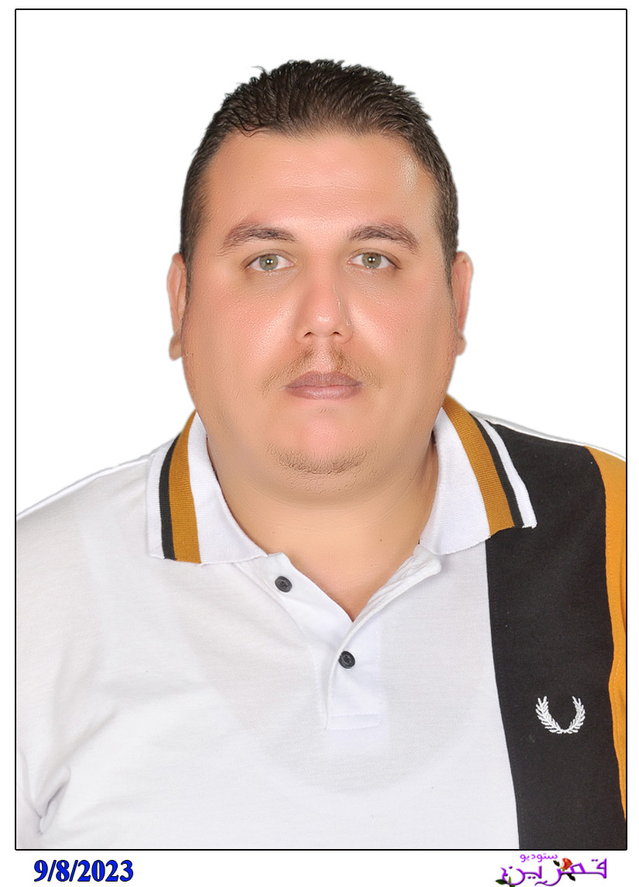
Application For Position as | ELECTRICIAN
Register Code. | ER-1.005
Other Position (If Any)
Register Date | 10/10/2023
Last up Date Data
Expected Salary

1. PERSONAL DETAILS
Full Name |  | FARAG ABDOU FARAG MESHKAH
Date Of Birth |  | 25/09/1987 |  |  |  |  |  |  | Place Of Birth |  |  |  |  |  |  |  | BEHAIRA
Nationality |  |  |  |  |  |  |  |  | Marital Status |  |  |  |  |  |  |  | Single |  |  |  |  |  |  |  | Married
Height (Cm) |  | 172 |  |  |  |  |  |  | Overall Size |  |  |  |  |  |  |  | XL |  |  |  |  | Shirt Size |  |  |  |  |  | XL
Weight (Kg) |  | 90 |  |  |  |  |  |  | Trouser Size |  |  |  |  |  |  |  | XL |  |  |  |  | Shoes Size |  |  |  |  |  | 44
2. EDUCATION
College / School
Marline Test |  | Issued Date |  |  |  |  | Result % |  |  |  | Issued By (Authority) |  |  |  |  |  |  |  |  |  | Issued At
English Language |  | Fluent |  |  |  |  |  | Good |  |  |  |  | Average |  |  |  |  |  |  |  | Poor
……… Language  ( ) |  | Fluent |  |  |  |  |  | Good |  |  |  |  | Average |  |  |  |  |  |  |  | Poor
3. CONTACT DETAILS
Home Address / City |  |  | Rasheed . BEHAIRA . Egypt
E-Mail |  |  | faragabdo690@gmail.com |  |  |  |  |  |  | Mobile / Tel |  |  |  |  |  | 002 01003668011 |  |  |  |  |  |  | 002 01125033011

4. TRAVEL DOCUMENTS
Type |  | Document No. |  |  |  | ISS. Date |  |  | Exp. Date |  |  |  |  | ISS. By (Authority) |  |  |  |  |  |  |  |  |  | Place of Issue
Passport |  | A 37479176 |  |  |  | 24/04/2024 |  |  | 23/04/20311 |  |  |  |  | Egyptian Authority |  |  |  |  |  |  |  |  |  | Egypt
Seaman Book |  | S00034102 |  |  |  | 27/08/2023 |  |  | 22/08/2028 |  |  |  |  | EAMS |  |  |  |  |  |  |  |  |  | Alex.
Other Seaman Book

5. PROFESSIONAL QUALIFICATION / CERTIFICATE OF COMPETENCY
Certificate Name |  |  |  |  | Number | Issue Date |  |  |  |  |  | Expiry Date |  |  |  |  |  | Issued By |  |  |  |  |  |  |  |  | Issued At
COC |  |  |  |  |  |  |  |  |  |  |  |  |  |  |  |  |  | EAMS |  |  |  |  |  |  |  |  | Alex.
GOC |  |  |  |  |  |  |  |  |  |  |  |  |  |  |  |  |  | NTRA |  |  |  |  |  |  |  |  | Cairo
D.P. INDUCTION
D.P. ADVANCED
D.P. OPERATOR (UNLIMITED)
6. NEXT OF KIN
Full Name | ABDOU FARAG MESHKAH |  |  |  |  |  |  |  |  |  |  |  |  |  | Relationship |  |  |  |  | Father
Address
Tel. No. |  |  |  |  |  |  |  |  |  | Mobile |  |  | 002 01003668011 |  |  |  |  |  |  |  |  |  | 01064047757
7. HEALTH CERTIFICATES & VACCINATIONS
Flag State |  |  |  | Number |  |  | Issue Date |  |  |  |  | Expiry Date |  |  |  |  |  |  | Issued By |  |  |  |  |  |  | Issued At
International Medical |  |  |  | 18686 |  |  | 04/09/2023 |  |  |  |  | 03/09/2025 |  |  |  |  |  |  | EAMS |  |  |  |  |  |  | Alex.
Yellow Fever |  |  |  | -- |  |  | 04/12/2014 |  |  |  |  | Valid for life long |  |  |  |  |  |  | Ministry of Health
Cholera |  |  |  |  |  |  |  |  |  |  |  |  |  |  |  |  |  |  | Ministry of Health
Covid-19 |  |  |  | Vaccination Name |  |  | First Dose |  |  |  |  | Second Dose |  |  |  |  |  |  | (Other Does or Remarks)

8. MARINE COURSES
Course Name | Number | Issue Date | Expiry Date | Issued By / At
Personal Survival Techniques | L 705358 | 21/08/2023 | 02/08/2028 | Arab Academy for Scince and Technology , Egypt.
Proficiency In Personal Survival Techniques
Fire Prevention and Fire Fighting | L 705358 | 21/08/2023 | 02/08/2028 | Arab Academy for Scince and Technology , Egypt.
Advanced Fire Prevention and Fire Fighting
Elementary First Aid | L 705358 | 21/08/2023 | 02/08/2028 | Arab Academy for Scince and Technology , Egypt.
Medical Care Studies
Personal Safety and Social Responsibilities | L 705358 | 21/08/2023 | 02/08/2028 | Arab Academy for Scince and Technology , Egypt.
Proficiency Of Security Awareness Training Seafarers | L 703196 | 14/08/2023 | 09/08/2028 | Arab Academy for Scince and Technology , Egypt.
Proficiency as a ship Security officer ( PSSO )
Proficiency In Survival Craft & Rescue Boats | L 894098 | 06/05/2025 | 22/05/2030 | EGYPTION AUTHORITY Arab Academy
G.M.D.S.S
Communications
Advanced Communications
ECDIS Advanced Simulator (Management Level)
ECDIS Simulator (Operation Level)
Prevention and Combating of Marine Pollution
Radar & ARPA Simulator and Search &rescue
ARPA Simulator and Search
Marine Radar and automatic Radar Plotting
Bridge resource Management (B.R.M)
Engine resource Management (E.R.M)
Navigational Watch keeping
Proficiency for Rating forming part of Navigational watch (II/4) |  |  |  | EAMS / Alex.
High voltage training – operation of ship (1000 Volt and More)
Passenger Safety Cargo Safety and Hull integrity
Crowd Management Training
Crisis Management and Human Behavior Training
Safety training for Personal Prov. Direct Passengers
Practical Ability to Prepare Meals and (MLC 2006)
Personal Hygiene and Envir. Protection (MLC 2006)
Safety and Health in the Provision Meals (MLC 2006)
Food Storage and inventory Control (MLC 2006)
Ships Cook Certificate (MLC 2006) |  |  |  | EAMS / Alex.
Abel Seafarer Deck
Proficiency for Abel Seafarer Deck ( II/5 ) |  |  |  | EAMS / Alex.
Engineering Watch keeping | L 527543 | 27/07/2020 | -- | Arab Academy for Scince and Technology , Egypt.
Proficiency for Rating forming part of a watch in engine room
Abel Seafarer Engine
Proficiency for Abel Seafarer Engine ( III/5 )
Electro Technical Rating | H 0025789 | 23/08/2023 | -- | NAVAL POST- GRADUATE STUDIES INSTITUTE, Egypt
Proficiency for Electro Technical rating ( III/7 ) |  |  |  | EAMS / Alex.
-SAFTY TRAINING FOR PASSENGER PROVIDING DIRECT SERVICE TO PASSENGER .. | S0012291 | 19/05/2025 | 12/05/2030 | NAVAL POST- GRADUATE STUDIES INSTITUTE, Egypt
-CROWED MANAGEMENT TRAINING. | S0012016 | 17/05/2025 | 09/05/2030 | NAVAL POST- GRADUATE STUDIES INSTITUTE, Egypt
-CRISIS MANAGEMENT AND HUMAN BEHAVIOUR TRAINING. | S0012156 | 18/05/2025 | 11/05/2030 | NAVAL POST- GRADUATE STUDIES INSTITUTE, Egypt
-PASSENGER SAFETY, CARGO SAFETY AND HULL INTEGRITY TRAINING. | S0012439 | 20/05/2025 | 14/05/2030 | NAVAL POST- GRADUATE STUDIES INSTITUTE, Egypt

COMPLETE SEA – SERVICE DETAILS

Name: |  |  |  |  |  |  |  | Rank: |  |  |  |  |  |  |  | Register Code:
Company Name |  | Rank |  |  | Vessel Name |  |  |  | Signed On |  |  | Signed Off |  |  |  | Period | Vessel Type |  |  |  | D.W.T. |  |  |  |  | Engine Type |  |  | BH |  | KW
ALGABRY SHIPPING CO. |  | ELECTRICIAN |  |  | ALBARKA 3 |  |  |  | 03/03/2012 |  |  | 10/12/2012 |  |  |  |  | LIVE STOK |  |  |  | 2000 |  |  |  |  | MAK
ALGABRY SHIPPING CO. |  | ELECTRICIAN |  |  | ALBARKA 1 |  |  |  | 27/11/2013 |  |  | 31/08/2014 |  |  |  |  | LIVE STOK |  |  |  | 4605 |  |  |  |  | MARKES |  |  | 3729
ALGABRY SHIPPING CO. |  | ELECTRICIAN |  |  | ALBARKA 8 |  |  |  | 22/11/2014 |  |  | 10/08/2015 |  |  |  |  | LIVE STOK |  |  |  | 1378 |  |  |  |  | MAK
HEGAZY SHIPPING CO |  | ELECTRICIAN |  |  | DELTA 1 |  |  |  | 11/03/2016 |  |  | 04/06/2017 |  |  |  |  | LIVE STOK |  |  |  | 5470 |  |  |  |  | MUTSIBISHI
ELRYDI |  | ELECTRICIAN |  |  | M/V SC II |  |  |  | 30/01/2018 |  |  | 21/05/2018 |  |  |  |  | ASMANT CARIOR |  |  |  |  |  |  |  |  | MAK
NABOLSI GROUP |  | ELECTRICIAN |  |  | M/V JOURI |  |  |  | 19/02/2018 |  |  | 03/06/2019 |  |  |  |  | G.CARGO |  |  |  | 9950 |  |  |  |  | MAK
GOHAR |  | ELECTRICIAN |  |  | RASHA |  |  |  | 28/06/2019 |  |  | 05/06/2020 |  |  |  |  | G.CARGO |  |  |  | 13696 |  |  |  |  | MUTSIBISHI
T TENERIFE CAR |  | ELECTRICIAN |  |  | M/V TENERIFE CAR |  |  |  | 26/03/2021 |  |  | 20/11/2021 |  |  |  |  | RO-RO |  |  |  | 13112 |  |  |  |  | WART SILLA |  |  | 13050
DIABCO MANGEMEN |  | ELECTRICIAN |  |  | M/V JERSY |  |  |  | 16/05/2022 |  |  | 10/10/2022 |  |  |  |  | LIVE STOK |  |  |  | 2924 |  |  |  |  | MAK |  |  | 1571
BELMONT MARINE |  | ELECTRICIAN |  |  | M/V JAOHAR ADAM |  |  |  | 31/10/2022 |  |  | 11/06/2023 |  |  |  |  | BULK |  |  |  | 29721 |  |  |  |  | B&W MUTSIBISHI |  |  | 6150
BAHR ELKHAIR |  | ELECTRICIAN |  |  | M/V SEA WAVE 1 |  |  |  | 14/10/2023 |  |  | 17/04/2024 |  |  |  |  | RO-RO |  |  |  | 7059 |  |  |  |  | WART SILLA |  |  | 4063
PHINEQIA |  | ELECTRICIAN |  |  | JAWHART BERLIN |  |  |  | 20-04-2024 |  |  | 21-08-2024 |  |  |  |  | Bulk |  |  |  | 26028 |  |  |  |  | MITSUI- MAN B&W 6S 50MC |  |  | 8311
GOHAR |  | ELECTRICIAN |  |  | M/V  AIPP GOLD |  |  |  | 05/09/2024 |  |  | 04/03/2025 |  |  |  |  | CONTAINER |  |  |  | 4028 |  |  |  |  | MAN B&W 4S |  |  | 3500
TENERIFE CAR |  | ELECTRICIAN |  |  | RO PRINCSS |  |  |  | 15/04/2025 |  |  | 15/09/2025 |  |  |  |  | RO-RO |  |  |  | 17020 |  |  |  |  | MAN B&W 8550 mc |  |  | 12640
SPECIALISED EXPERIENCE
Name |  |  |  |  |  |  |  |  |  | Type |  |  |  | From |  |  |  | To |  |  |  | Comments
I declare that the information I have given is, to the best of my knowledge, true and complete. I also declare that the documents submitted are genuine, given and sign by persons whose names appear on them.
 |  |  |  |  |  |  |  |  |  |  |  |  | 21/09/2025 |  |  |  |  |  |  |  |  |  | FARAG ABDOU  FARAG MESHKAH
 |  |  |  |  |  |  |  |  |  |  |  |  |  |  | DATE |  |  |  |  |  |  |  |  |  | SIGNATURE

